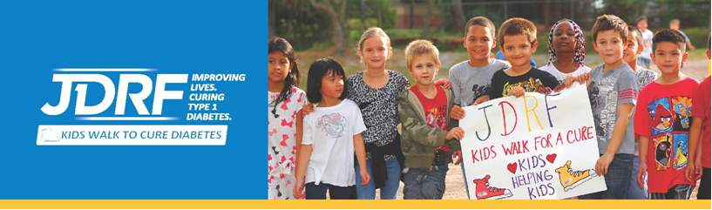
JDRF Kids Walk to Cure Diabetes - Send Fundraising Emails from your Participant Center in Five Easy Steps!

It’s as easy as 1–2–3-4-5! Use your Participant Center to help create a world without type 1 diabetes!
- Log in to your Participant Center at kidswalk.jdrf.org and select the “Send Emails” tab.

- Enter the email addresses of your friends and family in the “To” field. Or import your whole address book to save time and ask more people! Here are some handy tips for importing!
Google Gmail
Yahoo!
File-Based Import (Outlook, AOL, Hotmail, Apple, others)
Need help? Call us at 855-835-9255 or email onlinesupport@jdrf.org.

- Select a sample message that asks for donations. Or write your own!
- “Use a template” has several great emails already drafted.
- Remember, you are not asking for yourself. You are changing the world!

- Write an attention-grabbing subject line or “Please support (child’s name) for the JDRF Kids Walk.”
- Keep it short, preferably 50 characters or less.
- Avoid all caps or too much punctuation to keep it out of the spam box.
- Include your child’s name to make the email personal and ensure it gets opened.

- Hit “Send!”

Participant Center Highlights
- You can also use your JDRF Kids Walk Participant Center to TRACK your fundraising progress, CREATE your own personal fundraising webpage, ENGAGE your friends on Facebook, and much more!
- Don’t forget to FOLLOW UP! Everyone needs a friendly reminder. If you don’t hear from your friends in 3-5 days, send a FOLLOW UP EMAIL.
- Once those donations start to come in, say THANK YOU with another email message or write your own handwritten note! After all, it’s good manners!
REGISTER TODAY
KIDSWALK.JDRF.ORG

