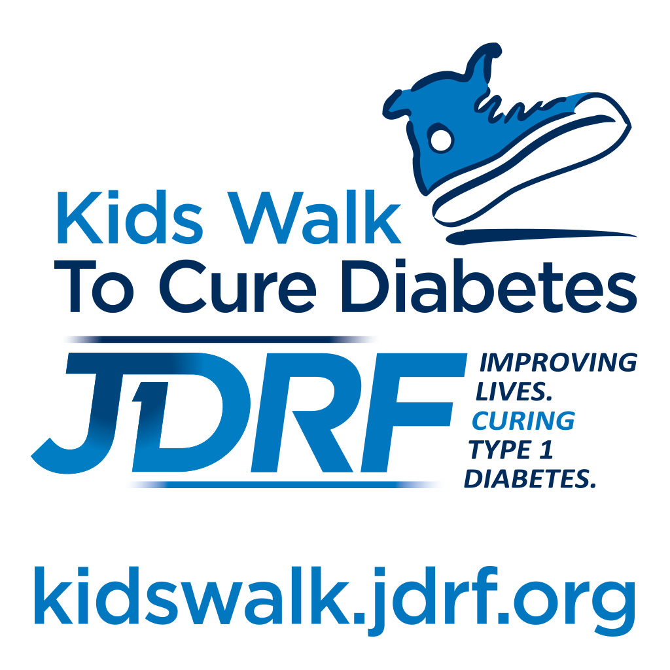

Kids Walk to Cure Diabetes
Walk Day Collection Procedures

INSTRUCTIONS FOR SCHOOL COORDINATORS

Introduction

Thank you for holding a JDRF Kids Walk to Cure Diabetes at your school! We are pleased to offer a procedure that allows for streamlined processing of funds and incentives! Please follow the instructions below in order to ensure that Kids Walk funds are sent securely and that your school’s incentives can be ordered properly.

Prior To Your School’s Kids Walks
- Contact your local JDRF Chapter (www.jdrf.org/locations) to obtain UPS labels for your upcoming Kids Walk.
- Ensure that you have the downloaded the accounting form located in “Resources for School Coordinators” section of the Resource Library and understand the process for sending funds. Please note that you must be logged into your Participant Center in order to download the form. If you have any questions, please contact your local JDRF Chapter.
Recommended Supplies

Extra Walk Collection Envelopes | Kids Walk Accounting Form
Tape | Shipping Label(s)
Stapler | Shipping box(es)
Pens
Ziploc Bags (for loose coins)
Calculator
Copy Machine

You may use whatever shipping boxes you have available, as long as they are in good condition and can be completely sealed. Each box should contain a maximum of $2,500 (estimated).

Staffing/Volunteer Needs

A minimum of two people is recommended for handling money turned in on the day of a Kids Walk.
This may include a JDRF staff member or volunteer, the School Coordinator, other school representative or school volunteer.

Collection Procedure

PLEASE DO NOT OPEN ANY ENVELOPES. ESTIMATES CAN BE OBTAINED BY ADDING THE TOTAL ON THE OUTSIDE OF EACH ENVELOPE. IF AN ENVELOPE IS INCOMPLETE, THE TOTAL WILL BE CALCULATED AT OUR PROCESSING FACILITY AND THE STUDENT WILL RECEIVE ANY APPLICABLE AWARDS.

- As the students turn in their collection envelopes, check to ensure that they are filled out completely. Be sure that each student’s name and grade level is included and that the grand total line is completed. DO NOT OPEN ENVELOPES. Note: If the total line is not completed by the student, the funds will be counted and credited to the student during processing. The student will receive any awards earned (if applicable).

- Once all envelopes have been collected, add the totals written on the collection envelopes and record the total on the Kids Walk Accounting form. Each form should have a “total in this box” amount of $2,500 or less written on it, as well as the overall grand total. This is meant to give you an approximate total for announcements and tell you the estimated amount of money that is being shipped. If any of the totals are not recorded on any of the envelopes, do NOT open them and do NOT write in the total. Ensure that all envelopes are sealed.

- Add any checks from the school from any school sponsored events such as coin collections, jean days, etc. to the “Amount of School Check” line on the form.

- Both people responsible for the collection MUST sign and print their names and titles at the bottom of the form.

- Fill out the Kids Walk Accounting Form for each UPS box.
Please have one filled out for each box and UPS label you are using. For example, If you have 5 boxes you will have 5 Kids Walk Accounting Forms. Each box should contain $2,500 or less (estimated). Keep a copy for your records.

- Place the envelopes in a shipping box(es).

- Boxes are to be picked up by UPS from the school location.

- Funds that come in post-Kids Walk should be sent to your local chapter office via regular mail (USPS).

Shipping Instructions

IMPORTANT: If a Kids Walk concludes at the end of the school day, the school should keep the funds in a safe, or a locked area to be shipped the next business day.

At the end of the Kids Walk, determine how many boxes will be used. Then use the following process to schedule a pick up and provide the correct number of shipping labels.

SCHEDULE A UPS PICK UP
Once your Kids Walk is wrapped up:
- If your school uses UPS service, schedule the UPS pick-up.
- If your school does not already utilize UPS, contact your local JDRF chapter to schedule UPS pick-up for you.
Note that UPS requires a 2-hour window for pick up.

AFTER YOUR KIDS WALK

On Kids Walk Day:
- Announce the preliminary total (based on the totals written on the collection envelopes) to the students and thank all teachers and school personnel involved in making the Kids Walk a success!

One to two weeks after the Kids Walk:
- Ensure that all funds have been turned in and that any additional funds have been mailed to the Chapter office via USPS.

Four to five weeks after the Kids Walk:
- Receive and distribute your school’s incentives: 10% appreciation check, banner and student Difference Maker Awards (as applicable).

Please direct questions to your local JDRF Chapter. Thank you for your support!

SAMPLE ENVELOPE

*Please make sure the following fields are filled out*

